ФЕДЕРАЛЬНОЕ АГЕНТСТВО ВОЗДУШНОГО ТРАНСПОРТА

ТРОИЦКИЙ АВИАЦИОННЫЙ ТЕХНИЧЕСКИЙ КОЛЛЕДЖ – филиал МГТУ ГА

УЧЕБНОЕ ПОСОБИЕ

ENGLISH

for aviation training

для курсантов, обучающихся по специальности СПО
«Техническая эксплуатация летательных аппаратов и двигателей»
по дисциплине: «Профессиональный английский язык»

Троицк
2022

Рассмотрено на заседании предметной комиссии
английского, русского языков и литературы
Протокол № …. от « …… » _____________ 2022 г.
Председатель предметной комиссии_________ И.М.Жмак

Рассмотрено и утверждено на заседании цикловой комиссии СЭД
Протокол № …. от « …… » ________ 2022 г.
Председатель ЦК СЭД _________Ю.В.Чалпанова

Составила: преподаватель ЦК СЭД И.М.Жмак

Пояснительная записка.
Данное учебное пособие предназначено для курсантов, обучающихся по специальности «Техническая эксплуатация летательных аппаратов и двигателей» в ТАТК – филиале МГТУ ГА. Учебное пособие составлено в соответствии с рабочей программой и календарно-тематическим планом дисциплины «Профессиональный английский язык», предусмотренных для обучения по специальностям СПО.
Цель данного пособия – формировать, развивать и систематизировать языковые компетенции, приобретенные в рамках изучаемого курса, подготовить выпускников к работе с технической документацией на английском языке в соответствии с требованиями работодателя по данной специальности.

Учебное пособие содержит:
- языковой, лексический материал по профессиональной тематике;
- базовую лексику и терминологию английского языка авиационной направленности, используемую в рабочих ситуациях, связанных с техническим обслуживанием самолетов;
- инструкции, руководства по конструкции воздушного судна для развития и совершенствования навыков перевода, обучения чтению;
- учебные задания, способствующие усвоению и активизации лексических и грамматических единиц в рамках тематики курса;
- словарь авиационной терминологии и лексических единиц.

UNIT 1
AIRCRAFT STRUCTURE
RANGE
Introduction
The 737—600/700/800/900 model is a two engine design. It is for short to medium range flights with a capacity of up to 149 passengers (737-800/900 = 189 passengers).
Features
There are many new features. These new features increase the airplane's pay-load, service ceiling and range.
The airplane has a design range of 2,900 to 4,200 nautical miles. Max. Cruising Speed M
0.78 Max. Cruising Altitude 41 000 ft

Structural Weight  Limitations in (kg) | B737- 700 | B737-800 | B737-900
Max. Taxi Weight MTXW | 60557 to 69628 | 70762 to78473 | 74616 to79243
Max. Takeoff Weight MTOW | 60328 to 69401 | 70535 to78246 | 74389 to79016
Max. Landing Weight MLAW | 58061 | 65318 | 66361
Max. Zero Fuel Weight MZFW | 54659 | 61690 | 63639

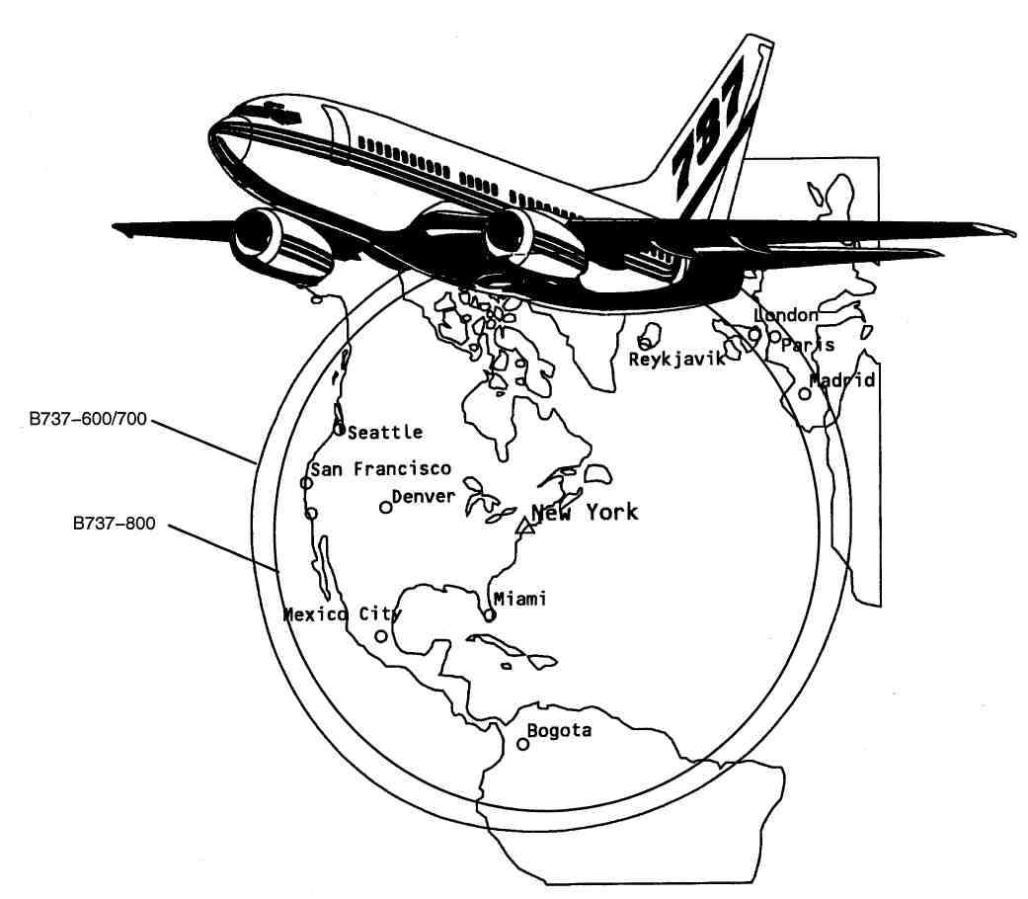

Figure 1 Range

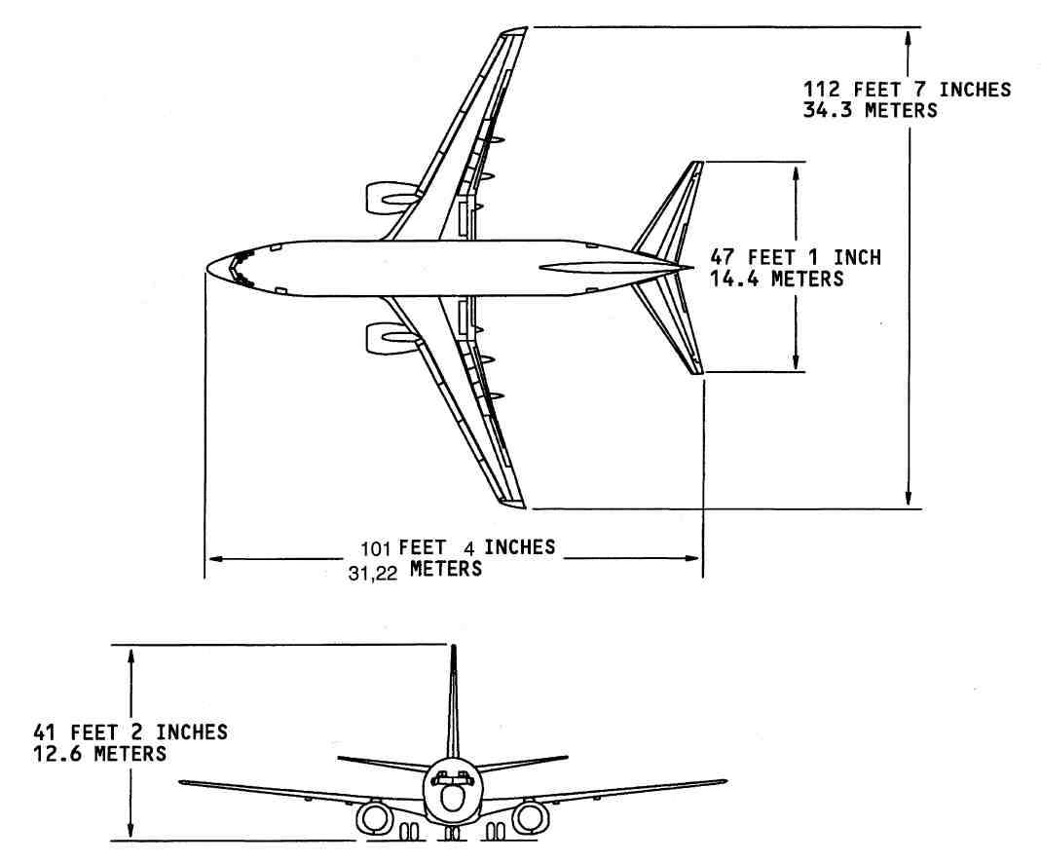

Figure 2 Dimensions B737-600

FUSELAGE DIMENSIONS

General Description
Dimensions give locations on the fuselage. The scale for each dimension is inches. You use these dimensions to find components on the fuselage:
- Body station line
- Body buttock line
- Water line.
The body station line (BS) is a horizontal dimension. It starts at station line zero. You measure the body station line from a vertical reference plane that is forward of the airplane.
The body buttock line (BBL) is a lateral dimension. You measure the buttock line to the left or right of the airplane center line (LBL or RBL).
The body water line (BWL) is a height dimension. You measure the body water line from a horizontal reference plane below the airplane.
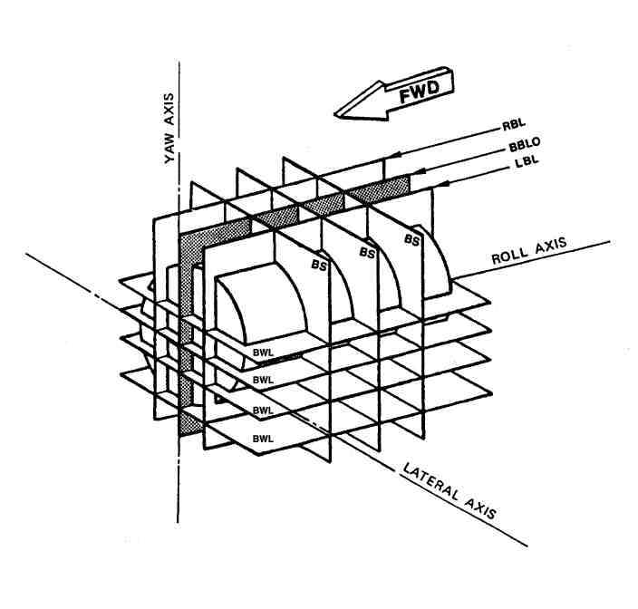

53-00 FUSELAGE INTRODUCTION  Major Zones  The 737 airplane is divided into 8 major zones to help you find and identify the airplane components and parts. The major zones are divided into subzones and the subzones into zones.  The zones are numbered in the sequence that follows:  - Fuselage - front to back and away from the floor line  - Wings - inboard to outboard and front to back  - Horizontal Stabilizer and Elevator - inboard to outboard and front to back  - Vertical Fin and Rudder - leading edge to the trailing edge of the vertical stabilizer  Each of the structural components, passenger compartment doors, cargo compartment doors, landing gear doors, rudders, elevators, flaps, ailerons, spoilers, leading edge devices, and equivalent components has a different zone number.  A three-digit number identifies the major zones, subzones, and zones as follows:  - Major Zone - the first digit is a number from 1 to 8 followed by two zeroes.  - Subzone - the first digit represents the major zone, the second digit is a number from 1 to 6 or 9, and the third digit is a zero.  - Zone - the first two digits represent the subzone number and the third digit shows a component or group of components that are in the sub-zone. | Access  Location Zones  - 100 Lower Half of Fuselage  - 200Upper Half of Fuselage  - 300 Empennage  - 400 Power plant and Nacelle Struts  - 500 Left Wing  - 600 Right Wing  - 700 Landing Gear and Landing Gear Doors  - 800Doors

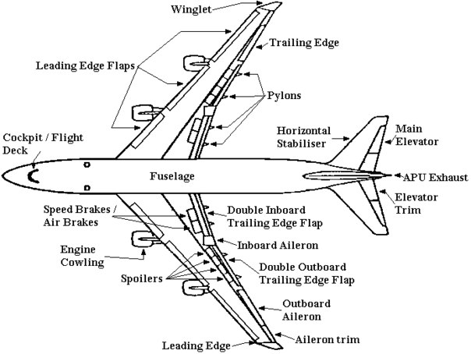

STABILIZERS
HORIZONTAL STABILIZER
Most of material In the horizontal stabilizer is aluminum. The elevator is graphite composite.
Horizontal Stabilizer Reference Dimensions
The horizontal stabilizer has three reference dimensions. These reference dimensions give horizontal stabilizer locations in inches. Measure each location from buttock line 0. These are the horizontal stabilizer reference dimensions:
• Stabilizer station
• Stabilizer leading edge station
• Elevator station.
Measure stabilizer stations perpendicular to the horizontal stabilizer rear spar.
Measure stabilizer leading edge stations perpendicular to the horizontal stabilizer leading edge. Measure elevator stations perpendicular to the elevator hinge centerline.
VERTICAL STABILIZER
Most of material in the vertical stabilizer is aluminum. The rudder is graphite composite.
Vertical Stabilizer Reference Dimensions
The vertical stabilizer has four reference dimensions. These reference dimensions give vertical stabilizer locations in inches. These are the vertical stabilizer reference dimensions:
• Vertical stabilizer station
• Vertical stabilizer leading edge station
• Rudder station
• Vertical stabilizer waterline.
Measure the vertical stabilizer station perpendicular to the vertical stabilizer rear spar. Vertical stabilizer station 0 starts at the body crown line.
Measure the vertical stabilizer leading edge station perpendicular to the vertical stabilizer leading edge. Vertical stabilizer leading edge station 0 starts at the body crown line. Measure the rudder station perpendicular to the rudder hinge centerline. Rudder station 0 starts at the body crown line. Measure the vertical stabilizer waterline parallel to the body waterline.
WINGS
General Description
The left wing Is shown. The right wing is almost the same. Most of material in the wing is aluminum. These components attach to the wing structure:
• Engine nacelle/pylon
• Flight control surfaces
• Wing tip.
• Wing Reference Dimensions
The wing has two reference dimensions. The reference dimensions give wing locations in inches. Measure each location from buttock line 0. These are the wing reference dimensions:
• Wing station
• Wing buttock line.
Measure the wing station perpendicular to the wing leading edge. You measure the wing buttock line parallel to the buttock line.
NACELLES-PYLONS
General
The nacelle is the fairings and the components that surround the engine. The nacelle gives an aerodynamically smooth surface to the strut and engine. The nacelle also contains these items:
• Inlet cowl
• Fan cowl
• Fan duct cowl and thrust reverser
• Primary exhaust nozzle
• Exhaust plug.
The pylon is the strut that attaches the engine to the wing. The strut also contains these items:
• Fuel lines
• Electrical lines
• Hydraulic lines
• Pneumatic ducts
• Fairings
• Fire detection/extinguish lines.
Nacelle stations and waterlines give locations on the nacelle-pylon. The scale for nacelle stations and waterlines is inches. The station line is a horizontal dimension. It starts at station line zero.
The water line is a height dimension. You measure the water line from a horizontal reference plane below the nacelle-pylon.
DOORS — INTRODUCTION  Purpose  The doors are removable units that give access to the airplane compartments.  General Description  These are the types of doors on the airplane:  - Forward and aft entry doors  - Forward and aft galley service doors  - Emergency exit hatches (and pilots' sliding windows)  - Cargo doors  - Interior doors (crew door and lavatory doors)  - Miscellaneous access doors.  A door warning system shows the crew that pressure bearing doors are closed and properly latched before flight.  All doors have silicon rubber seals. The seals do these things:  - Seal air and light leaks  - Act as acoustic and thermal barriers  - Supply aerodynamic smoothness.  See the main gear and doors section for more information on the landing gear doors.(AMM PART I 32— 10)  Location  The entry doors are on the left side of the airplane.  The galley service doors are on the right side of the airplane.  The emergency exit hatches are above the wings on both sides of the airplane. The pilots' sliding windows are in the flight compartment.  The crew door and lavatory doors are inside the airplane. The cargo doors are on the right side of the airplane.  The miscellaneous access doors are near the systems they serve. | Training Information Point  You can open and close entry, galley service, and cargo doors in winds up to 40 knots without structural damage. You can let these doors stay latched open in winds up to 65 knots without structural damage.  If a door is left open for a long time, a protective cover should be put over the door frame. This prevents bad weather damage to the airplane.

DOORS MULTIPLE USE SYSTEMS/UNITS
DOORS — DOOR SEALS
Purpose
The door seals do these things:
- Stop air leaks (pressure seals)
- Stop light transmission (light seals)
- Reduce noise transmission (acoustic seals)
- Reduce thermal transmission (thermal seals)
- Improve aerodynamic smoothness (aero seals).
General Description
Door seals are flexible materials made of cloth and glass fiber reinforced silicon rubber. The seals are made in many forms to meet the requirements of their function. These are the common types of seal shapes:
- Bulb—type seals
- Diaphragm seals
- Flap—type seals (Blade seals)
- Multiform seals (combination of forms).
Door seals are held in place by one or more of these things:
- Adhesive compounds (fay surfaces and edges)
- Screws (with or without backing plates)
- Flanges and channels (plain or rod—and—socket).
Location
Door seals are used where it is necessary to cover the spaces on or around a door or panel. These are the typical locations of door seals:
------Over door and panel hinges (diaphragm type)
----- Around door and panel edges (flap, blade, and bulb types)
----- Around door and panel frames (flap, blade, and bulb types).
Functional Description
Door seals are flexible materials that fill the spaces between mechanical parts. They are resilient materials that work by elastic deformation.

Training Information Point
Liquid soap is a good, non staining lubricant form seals.A lubricant can be useful for the reasons:
- To make installation easy
- To extend the service life of the seal.

PASSENGER/CREW

FORWARD ENTRY DOOR — INTRODUCTION
Purpose
The forward entry door gives access to the airplane passenger cabin.
Location
The forward entry door is on the left side of the upper, forward fuselage.
General Description
The forward entry door is the largest passenger entry door on the airplane. The door is a plug—type door. The door has these parts:
- Center door assembly
- Upper gate
- Lower gate.
A liner covers the door is interior surface.
The center door assembly has hard points at the bottom for the emergency escape slide installation.
The center door assembly has a window.
Door Control Mechanisms
You can open and close the door from the interior or exterior of the airplane. You operate the door manually. Unlatch the door with the control handle.
When you turn the handle in the OPEN direction, internal mechanisms do these things:
- Disengage the door roller latches
- Fold the door gates inward
- Tilt the door's hinge edge inward to the cocked position.
Then push the door through the door frame until it is fully open. Use the assist handles for this operation.
A lock mechanism in the upper hinge locks the door in the fully open position.
Door Support
When the airplane is unpressurized, the hinges support the door.
When the airplane is pressurized, cabin pressure pushes the door slightly outboard. This causes these things to occur:
- The door seals compress
- The door stop pins contact frame stop fittings. This transmits the door pressure loads to the door frame structure
- The door latches are unloaded.
Door Seals
The door has these seals:
- Edge seals (flap and bulb type)
- Gate hinge seals (diaphragm type).
HANDLE MECHANISM
Purpose
The handle mechanism does these things:
- Moves a closed and latched door to the cocked open position
- Moves a door in the cocked open position to the closed and latched position.
Location
The handle mechanism is between the interior and exterior control handles.
Physical Description
The handle mechanism has these major parts:
- Interior and exterior control handles
- Cam plate
- Door latching crank and cam roller rocker
- Door cocking crank and cam roller rocker
- Door latching crank and pushrods
- Door cocking crank and pushrod
- Door hinges and torque tube
- Upper and lower door gates, pushrods, and stoprods
- Associated shafts, bearings, retainers, springs, and fasteners.
Functional Description
You operate the door handle mechanism manually. The interior handle turns the cam plate.
The exterior handle fairs in a recess in the outer skin of the door. It is spring— loaded to this position. When faired, the door handle disengages the cam plate. When you pull the handle from the faired position, it engages the cam plate by a spline drive. When the handle spline drive engages, the handle turns the cam plate.
The cam plate has two different cam tracks:
- One track drives the door latching roller rocker
- The other track drives the door cocking roller rocker.
When the cam plate turns in the open direction, it causes these things to occur:
- The door unlatches and its gates fold
- The door moves to the cocked open position.
Training Information Point
The force on the control handle to open and close the door is not large. If a large force is required, there is a fault with the door or the procedure.
If the door does not close and latch easily, there may be a clearance problem. Make sure the door—to—frame area is clear. An incorrectly stowed escape slide girt strap may be caught between the door and the frame.
If the airplane is pressurized, a properly rigged door will not unlatch. This is because the door gates must open against cabin pressure during door unlatch. Pressure on the door gates has a mechanical advantage and prevents this.
From the cocked position, push the door through the door frame with the assist handles. Do not use the control handle to push or pull the door through the door frame. This puts too much stress on the door hub.
CARGO

CARGO COMPARTMENT DOORS — INTRODUCTION

Purpose

The cargo doors give access to the cargo compartments, location

Location

The cargo compartment doors are on the right side of the fuselage, on the lower
lobe, forward and aft of the wing.
General Description
There are two cargo doors:
- The forward cargo door
- The aft cargo door.
The doors are similar in shape, design, and operation, but they are slightly different in
size.
The doors are plug—type. They open inward, and hinge at the top. Seals around
the door edge and door handle shaft prevent pressurization loss.
You operate the doors manually. This may be done from outside of the airplane or
from inside the cargo compartment. A counter balance assembly inside the door
reduces the effort required to lift the door. An uplock detent in the counter balance
mechanism holds the door in the fully open position. A door snubber prevents the
door from falling quickly if the counter balance mechanism fails.
A manual strap device in the cargo compartment ceiling can be used to hold the door in the fully open position.
A bungee lanyard with a soft—grip handle on the door makes it easy to lower the
door.

Door Warning

The cargo doors have an interface with the door warning system. Each door has a switch on its latch mechanism, and a warning light on the P5 panel.

Access Panels and liners

Two panels on the exterior door skin give access to the door latch mechanisms.
Through these panels, you can open the door if the handle mechanism fails. A interior insulation blanket on the door does these things:
- Protects the door internal components
- Reduces noise and thermal transmission.
Removal of the door insulation and access panels gives access to the door internal
components. This is for inspection, lubrication, and service of the internal components.

UNIT 2
ENGINE/ POWER PLANT
General Description
Two CFM56—7B engines supply thrust for the airplane. The engines also supply power for these systems:
-Electric
-Hydraulic
-Pneumatic.
The CFM56—7B is a high bypass ratio, dual rotor, turbo fan engine.
Engine Thrust Ratings and Aircraft Model Application
A limited number of the six engine thrust rating configurations are applicable to a 737 model. The different engine thrust ratings are based upon airplane weight and elevator/rudder control limits. The longer-body 737-800 and 737-900 models can operate at the maximum thrust capability of the CFM56-7B engine. Also, the lowest thrust rating is not sufficient for the 737-700, 737-800, 737-900.
Aircraft Models
The normal models are 737-600, 700, 800 and 900. Some other variations will be 737-700 IGW (increased gross weight), and 737-700 BBJ (Boeing business jet).
Engine Thrust Rating
By design, all 7B engines can produce a take-off thrust of 27,300 lbs. Specific contacts within the identification plug enable various thrust ratings, which are: B18: 19,500 lbs 737-600. (lbs— pounds)
- B20 : 20,600 lbs 737-600 & -700.
- B22 : 22,700 lbs 737-600 & -700.
- B24 : 24,200 lbs 737-700 & -800 & -900.
- B26 : 26,300 lbs 737-800 & -900 & -BBJ & COMBI & C40A.
- B27 : 27,300 lbs 737-800 & -900.

Bump Option for the -7B22 B1, -7B24 B1, -7B26 B1.
Bump is an Option provided to achieve power levels greater than the normal take-off levels within specific limitations. The bump rating does not influence power levels which are at, or below Max. Continuous Thrust. For any available bump, the redline values (N1, N2, EGT) remain identical to the baseline rating.

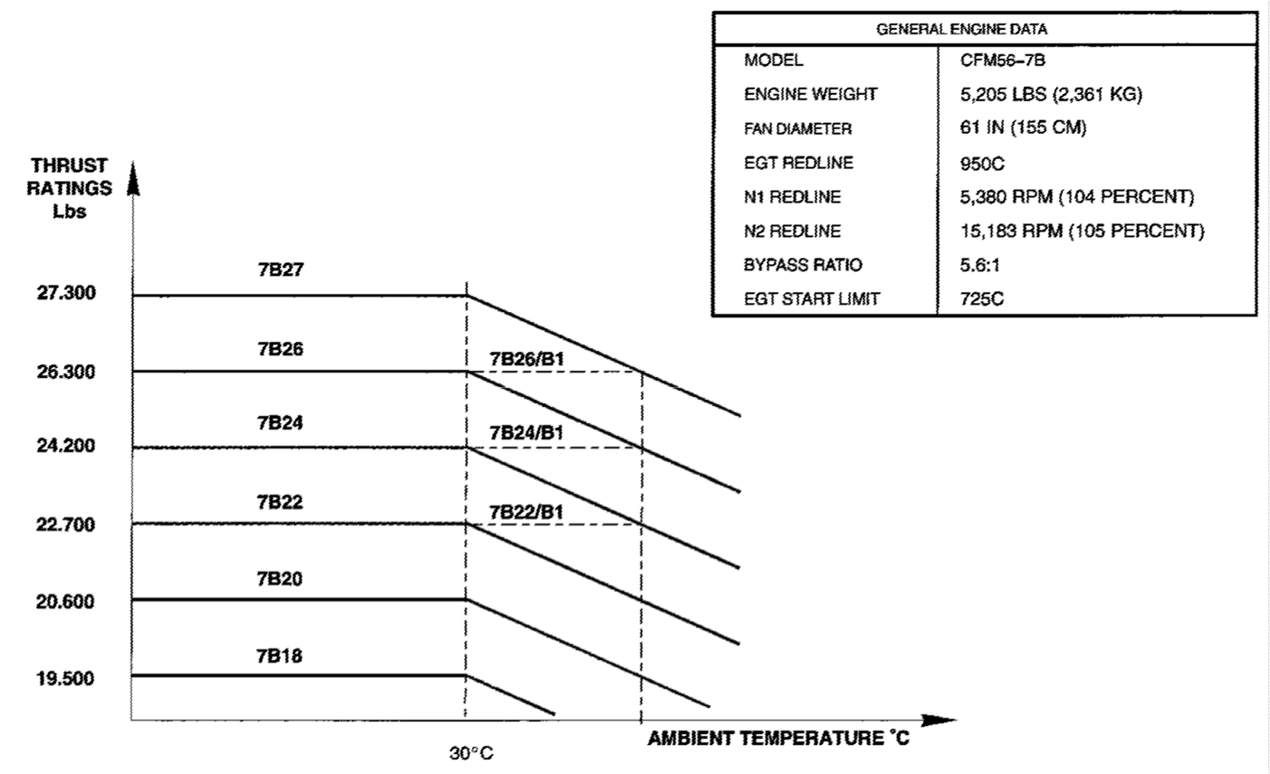

Figure 1 Thrust Rating

Engine Nameplate
General engine data for the CFM56—7B engine is shown. These items show on the engine nameplate:-Regulatory agency data-Engine manufacture data-Engine performance data.
The regulatory agency data blocks used depend upon where the engine was assembled. For engines assembled by G.E. the two upper right blocks will be used. For engines assembled by SNECMA, the two upper left blocks will be used. The serial number will be filled every time. The first line of seven blocks will be filled at the assemble plant. The version of the engine will be in the CONFIG space. The second and third blocks show takeoff and Max continuous thrust in Metric (daN) thrust ratings. The fourth and fifth blocks show takeoff thrust and the Max continuous thrust in pounds (LB). Block six shows the N1 trim applied to that engine. The last block is for service bulletins applied to this engine. The lower three blocks show the manufacturer data. The second block shows the manufacturer of the engine. For engines assemble by General Electric, the block shows G.E. CO. Engines assembled by SNECMA, the block shows SNECMA. Six additional rows are available to show changes to the engine. This permits six different thrust rating changes before you must replace the nameplate. The nameplate also shows the thrust rating history of the engine.
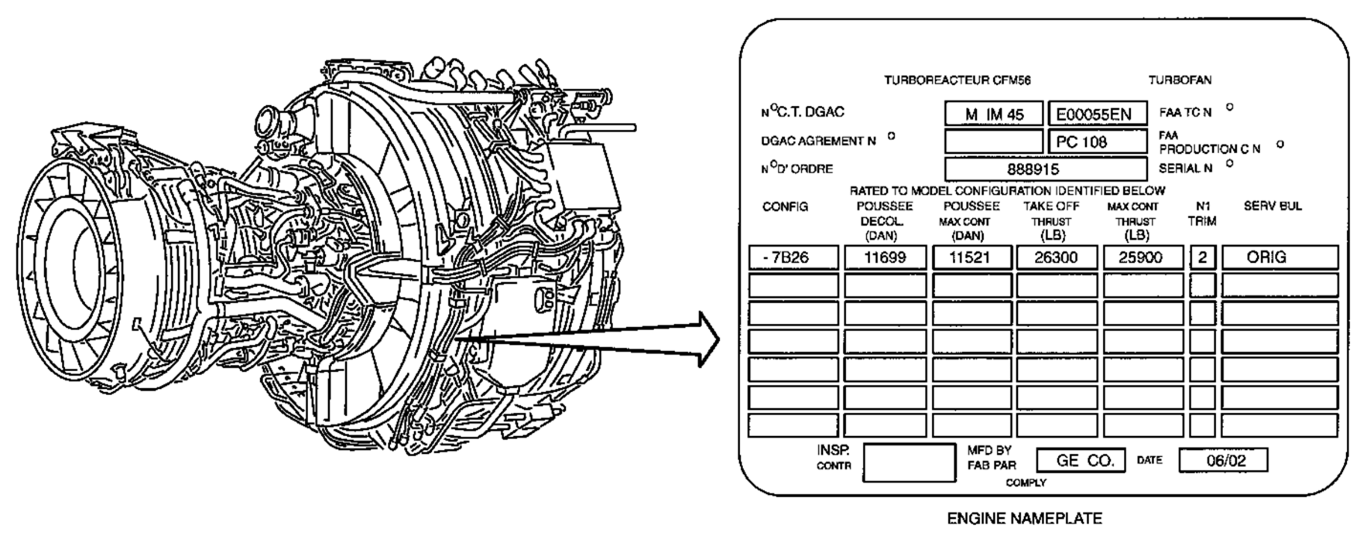
Figure 2 Engine Nameplate
Engine – General Description
The CFM56- 7 Is a high bypass, dual rotor axial flow turbofan engine. The engine fan diameter is 61 inches (1.55 meters). The bare engine weight is 5257 pounds (2385 kg). The engine has these sections:
-Fan and booster
The fan and booster rotor and the LPC rotor are on the same low pressure shaft (N1). The fan and booster is a four- stage compressor The fan increases the speed of the air. A splitter fairing divides the air into these two air flows:
-Primary
The primary air flow goes into the core of the engine. The booster increases the pressure of this air and sends it to the HPC.
-Secondary.
The secondary air flow goes in the fan duct. It supplies approximately 80% of the thrust during take- of.
-High pressure compressor (HPC)
The HPC rotor and the HPT rotor are on the same high pressure shaft (N2). The HPC is a nine- stage compressor It increases the pressure of the air from the LPC and sends it to the combustor. The HPC also supplies bleed air for the aircraft pneumatic system and the engine air system.
-Combustor
The combustor mixes air from the compressors and fuel from the fuel nozzles. This mixture of air and fuel burns in the combustion chamber to make hot gases. The hot gases go to the HPT.
-High pressure turbine (HPT)
The HPT is a single- stage turbine. It changes the energy of the hot gases into a mechanical energy. The HPT uses this mechanical energy to turn the HPC rotor and the accessory drive.
-Low pressure turbine (LPT)
The LPT is a four- stage turbine. It changes the energy of the hot gases into a mechanical energy. The LPT uses this mechanical energy to turn the fan and booster rotor.
- Accessory drive. The accessory drive has these components:
- Inlet gear box (IGB)- Radial drive shaft (RDS)- Transfer gear box (TGB)- Accessory gear box (AGB).
FADEC System Introduction
FADEC Purpose
The CFM56-7B operates through a system known as FADEC (Full Authority Digital Engine Control). It takes complete control of engine systems in response to command inputs from the aircraft. It also provides information to the aircraft for flight deck indications, engine condition monitoring, maintenance reporting and troubleshooting.
-It performs fuel control and provides limit protections for N1 and N2.
-It controls the engine parameters during the starting sequence and prevents the engine from exceeding starting EGT limits (aircraft on ground).
-It manages the thrust according to 2 modes:
-manual and
-autothrust.
-It provides optimal engine operation by controlling compressor airflow and turbine clearances.
-Finally, it controls the 2 thrust lever interlock solenoids.
Engine Ground Safety Precaution
The operation of jet power plants is dangerous. There is a very strong suction at the front of the engine that can pull persons and unwanted materials into the air inlet.
-Very hot, high speed gases go rearward from the turbine exhaust nozzle.
-The fan exhaust at high thrust has very high speed.
-When the thrust reverser is extended, the fan exhaust goes forward while the turbine exhaust is goes rearward.
Air Inlet
Figure shows the hazard areas near the air inlet with dangerous air conditions. Inlet hazard areas are shown on the left and right fan cowl panels with stripes and placards. Persons positioned near the power plant during power plant operation must be aware of the hazard areas aft of the inlet cowl lip.
-This hazard area extends completely around the outer diameter and to the forward end of the power plant.
-At idle power, the hazard areas start four feet aft of the inlet cowl lip.
-At above idle power, the hazard areas start five feet aft of the inlet cowl lip.
-If the surface wind is more than 25 knots, increase the distance of the hazard area by 20%.
-If the ramp surfaces are wet or frozen, make the ramp clean to prevent injury to persons.
Air Exhaust
When the engine operates, a large quantity of exhaust comes from the aft end of the engine. The exhaust is hot and moves at high speed. There are contamination and bad gases which were pulled into the engine by suction. There are gases from the fuel that has burned or fuel which has not burned. At high power, the fan and turbine exhaust can blow loose dirt, stones, sand and other unwanted materials a distance of 300 feet. The airplane must be parked at an area where injury to persons or damage to equipment or other airplanes can be prevented. Use a blast fence to deflect the thrust if the engines are operated without sufficient space to decrease the fan and turbine exhaust thrust to zero. High temperature exhaust can be found 300 feet from the exhaust nozzle with the correct wind conditions. The exhaust temperature near the engine is sufficient to melt bituminous (asphalt) pavement. Concrete pavement is recommended. When an engine is started, fuel that has collected in the turbine exhaust sleeve can ignite. Long flames are blown out of the exhaust nozzle. All flammable materials must be kept clear of the exhaust nozzle.
Warning: All persons must stay out of the dangerous areas that are aft of the power plant. During the engine operation, there are hot gases and high speed air which can cause injury to persons and damage to equipment.
Engine Entry/Exit Corridor
Engine entry corridors are between the inlet hazard areas and the exhaust hazard areas. You should go near an engine in operation only when:
-The engine is at idle
-You can speak with people in the flight compartment.
For additional safety, wear a safety harness when the engine is in operation. Usually, when the engine is in operation, the anti- collision lights are on.
Engine Aerodynamic Stations
The EEC requires information on the engine gas path and operational parameters in order to control the engine during all flight phases. Sensors are installed at aerodynamic stations and various engine locations, to measure engine parameters and provide them to the EEC subsystems. Sensors located at aerodynamic stations have the same number as the Station e.g. T25. Sensors placed at other engine locations have a particular name e.g. T case sensor.
There are probes or sensors at these 7 aerodynamic stations on the CFM56-7.
-Station 0 (ambient air)-Station 12 (fan inlet)-Station 13 (fan discharge)-Station 25 (high pressure compressor inlet)-Station 30 (high pressure compressor discharge)-Station 49.5 (stage 2 low pressure turbine stator)-Station 50 (low pressure turbine discharge).
Main Engine Bearings
Five main engine bearings hold the N1 shaft and the N2 shaft. Numbers from 1 to 5 identify the engine bearings. Ball bearings absorb the axial and the radial loads from the shafts. Roller bearings absorb only radial loads. The main engine bearings are in two sump cavities.
-Three bearings are in the FWD sump. Bearing #1, #2 and #3.
-Two bearings are in the AFT sump. Bearing #4 and #5.
Fan Blades and Spinners
Front and Rear Spinners
The front and rear spinners are aerodynamic fairings which direct engine inlet airflow.
Fan Blades
There are 24 wide- chord, titanium fan blades. A spacer shim under each fan blade holds it in the correct radial position. You remove the spacer shim to make it easier to remove the fan blade. The platforms between the blades make the airflow smooth. The fan retaining flange and retaining ring holds the fan blade spacer shims and platforms. You read this information engraved under the root of the fan blade:-Part number-Serial number-Momentum weight.
When you remove or replace fan blades, record the position and the serial number of the blades. That lets you do these tasks:
-Install the blades you removed in the same position to keep the engine in balance
-Calculate the spare blades position and the momentum weight correction when you replace blades.
Balance Weight Screws
You balance an engine with balance weight screws. You install the balance weight screws on the rear spinner.
Offset Holes
The offset holes let you install the spinners and the locking retainer in only one correct angular position. Spherical indents show the offset holes. There are offset bolt holes or threads on these components:-Front spinner-Rear spinner-Locking retainer-Fan disk.
Training Information Point
You must remove the spinner front cone to remove the spinner rear cone. You remove the spinner rear cone, fan retaining flange and the retaining ring to get access to the fan blades. You must remove the adjacent platforms and the fan blade spacer shim to remove a fan blade.
Boeing 737-600/700/800/900 Type Training B1 ATA 71-80

Ear Protection

Warning: Use ear protection when the engine operates. The engines make sufficient noise to cause damage to your ears.
- You can temporarily cause your ears to become less sensitive to sound, if you listen to loud engine noise.
- You can become permanently deaf if you listen to the engine noise for a long time.
- Noise can affect the ear mechanism and cause unsteadiness or an inability to walk or stand without reeling.
- When you are near an operating engine, always use ear protection to decrease the quantity of sound energy which reaches your ears.
Note: The use of cup-type ear protection is recommended.

Engine Controls

General Description

The engine control system supplies manual and automatic control inputs to control the engine thrust. It also supplies signals to other airplane systems that
require engine control status. The engine control system has these components:
- Thrust levers (forward and reverse)
- Engine start levers and switches
- Thrust lever interlock solenoids.

Thrust Levers
You use the thrust levers to supply the manual inputs to the engine control system. There are two thrust lever assemblies, one for each engine. For each engine,
there is a forward thrust lever and a reverse thrust lever. The reverse thrust lever is on the forward thrust lever. For each engine, the thrust levers
supply a thrust command signal to the electronic engine control (EEC) through a resolver. Each thrust lever assembly connects mechanically to a resolver
through an adjustable rod. An interlock latch prevents the operation of the forward thrust lever and the reverse thrust lever at the same time.

Start Levers

There are two start levers, one for each engine. You use the engine start lever during an engine start. You also use it to shutdown the engine. The start
levers operate switches which supply signals to different aircraft and engine systems and components.

Reverse Thrust Interlock Solenoids
There are two reverse thrust interlock solenoids, one for each engine. Each reverse thrust interlock solenoid limits the range of motion of a reverse thrust
lever. You can make the thrust reverser deploy, but you can not increase the reverse thrust until the thrust reverser sleeves are near the full deployed
position. The EEC operates the solenoids. The thrust lever interlock solenoids are in the autothrottle assembly. You must remove the autothrottle assembly
to access the thrust lever interlock solenoids. See the thrust reverser section for more information. (AMM PART I 78—31) See the autoflight chapter for more information on the autothrottle system.
Oil Distribution

OIL Tank
These are the functions of the engine oil tank:
- Contain the engine oil
- Remove the air from the scavenge oil
- Lets you do an oil level check and fill the oil system.

Component Location
The engine oil tank is on the fan case, at the 3:00 position. You do the
oil level check and you fill the oil tank through the oil tank access door.
The oil tank access door is on the side of the right fan cowl. You can
also open the right fan cowl to get access to the all oil tank.
TASK 1. Learn these words and expressions
power plant, engine mount, engine cowlings, fairings, nacelle, pod,feed system, fire prevention system,anti-icing device, altitude,load-carrying capacity
2) 1. What does the power plant include?
2. What do types of engines, their number and location on the plane depend on?
3. Where are engines mounted?
4. What is the power plant bolted to?
5. Where is the firewall?
6. What for is the firewall?
7. What are the cowlings made of?
3) Complete the sentences using correct variant:
1. The power plant includes…
a) an engine, propeller, cowlings, fairings, feed system, cooling system
b) cockpit, nose gear, tail unit
c) wing-flaps, wing-tips
2. Engines are mounted in the:
a) wing and on the wing-tips, under the wing, beneath the wing
b) in a passenger cabin
c) in the cargo hold
3. The power plant is bolted to an:
a) cockpit
b) flat
c) engine mount
4) Put questions:
1. The power plant is bolted to an engine mount.
2. Engine mount vary widely in appearance and construction.
5) Put the sentence in to past and Future forms. The engine is mounted to the strut.

UNIT 3
FLIGHT CONTROLS
Flight Controls – Introduction
General
The flight controls keep the airplane at the necessary attitude during flight. They have movable surfaces on the wing and the empennage. These are the two types of flight control systems:-Primary ,-Secondary.
Primary Flight Control System
The primary flight control system moves the airplane about three axes: lateral, longitudinal, and vertical. The primary flight control system has these components:-Aileron (2),-Elevator (2), -Rudder.
Secondary Flight Controls
The secondary flight controls improve the lift and handling properties of the airplane. The secondary flight control system has these components:
-Leading edge devices (12)
-Trailing edge flaps (4)
-Spoilers and speedbrakes (12)
-Horizontal stabilizer.
Abbreviations and Acronyms
A/P — autopilot  A/S — airspeed  C/W —control wheel  cntl — control  gnd — ground  LE — leading edge | MLG —main landing gear  NLG — nose landing gear  Pcu —power control unit  S/B — speedbrake  Sov — shutoff valve  stab — stabilizer  sec — section  TE — trailing edge  vlv —valve

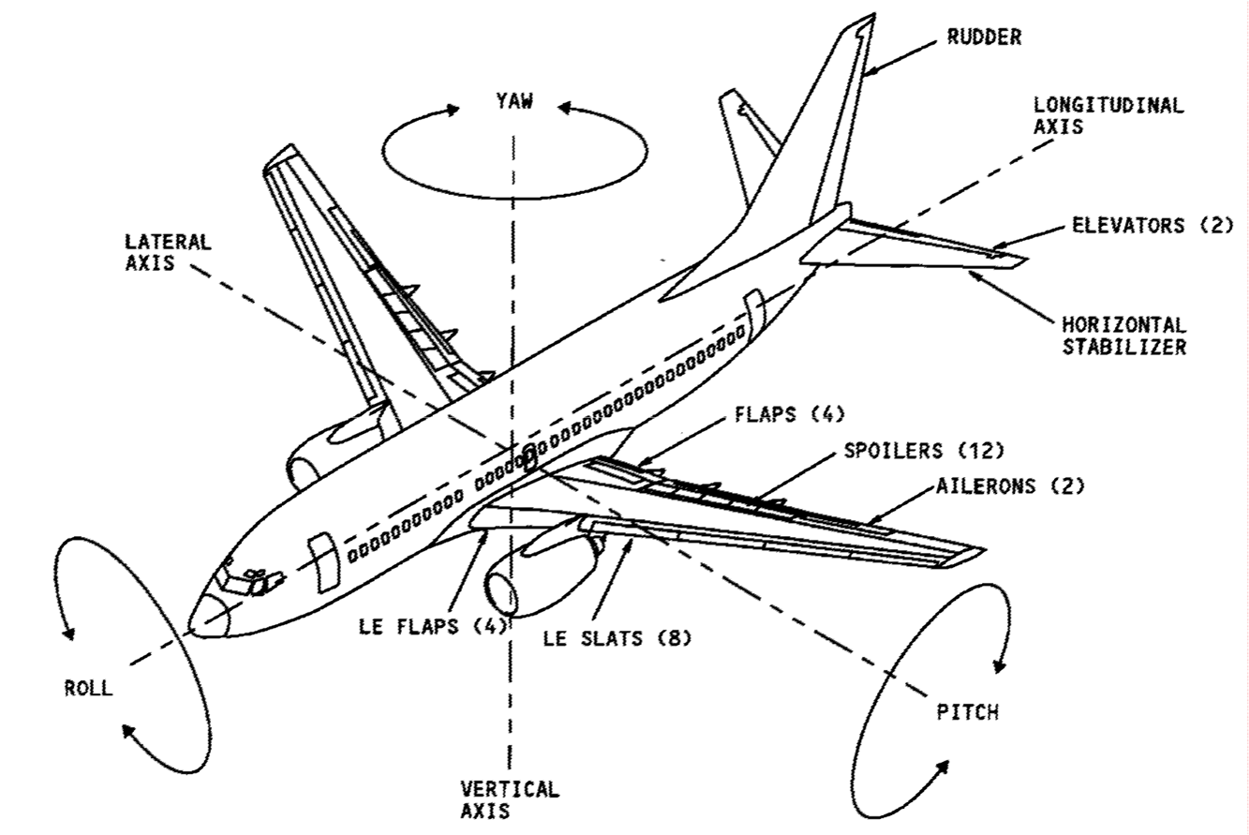

Figure 1 Introduction
General Description
General
The pilots manually operate the flight controls through cables. The autopilot automatically operates them.
Aileron
The aileron control wheel moves the left body cables. This controls the feel and centering unit. This controls the aileron PCUs. The PCU moves the aileron wing cables and the ailerons. Aileron PCU movement also goes to the spoiler mixer. The mixer moves the flight spoiler wing cables, which control the flight spoiler PCUs. The PCUs move the flight spoilers to assist the ailerons for roll control. The autopilot actuators give a mechanical input to the PCUs through the feel and centering unit. The PCU housing moves the wing cables, the ailerons, and the flight spoilers.
Elevator
The control columns move cables that control the PCUs. Then the PCU moves the elevators. The autopilot actuators give mechanical input to the PCUs through the feel and centering unit. The PCU moves the elevators.
Rudder
The rudder pedals move cables that control the PCUs. Then the PCU piston moves the rudder.
Flaps and Slats
The flap control lever moves the trailing edge flap control valve. Hydraulic pressure goes through the valve and drives the hydraulic motor. Then the flaps move. At the same time, follow—up cables give input to the leading edge control valve. Then hydraulic pressure goes to the leading edge actuators. This controls the position of the leading edge devices. The alternate flap switches electrically control the trailing edge flaps. They also control the standby system to extend the leading edge flaps and slats.
Spoilers and Speedbrakes
The speedbrake lever moves cables that control the spoiler mixer. The mixer moves the spoiler wing cables that control the flight spoiler PCUs. The mixer also moves the ground spoiler control valve, the valve supplies pressure to the ground spoiler PCUs to raise the spoilers. During automatic deployment, the auto speedbrake actuator gives input to the same cables as above.
Horizontal Stabilizer
The stabilizer trim wheels move cables that give input to the gearbox. The gears move the stabilizer. The electric trim switches control an electric motor near the gearbox. The motor moves the gears to move the stabilizer. When the stabilizer moves, it also moves the elevators through the elevator feel and centering unit.
Flight Comp. Controls & Indications – 1 General
The flight control indication and control components are in the flight compartment.
Aileron
The aileron control wheel is on the top of the elevator control column. The aileron trim indication is on the top of the control wheel.
Elevator
The elevator control columns are forward of the pilot seats.

Rudder
The rudder pedals are forward of the pilot seats.
Flaps and Slats
The alternate flap switches are on the flight control panel on the P5 forward overhead panel. The indication for the leading edge devices is on the P5 aft overhead panel. The trailing edge flaps indication is on the P2 center instrument panel.
Spoilers and Speed brakes
A green SPEED BRAKE ARM light and an amber SPEED BRAKE DO NOT ARM light are on the PI panel. The SPEEDBRAKES EXTENDED light is on the P3 panel.
Horizontal Stabilizer
The electric trim switches are on the outboard side of each control wheel.
Stall Warning
The stall warning test switches are on the P5 aft overhead panel.
Systems/Units
System/Units Introduction
General
The flight controls system has some multiple use components. This section supplies information for these multiple use components:
-Flight control cables
-Flight control panel
-Flight control hydraulic modular packages.
Flight Control Cables
You use the flight control cables to give manual input to each flight control system.
Flight Control Panel
The flight control panel has hydraulic control switches and caution lights for several of the flight control systems.
Flight Control Hydraulic Modular Packages
The two flight controls hydraulic modular packages control and monitor hydraulic pressure to the flight controls. Each package contains these components:
-Flight controls shutoff valve,-Low pressure warning switch, -Spoiler shutoff valve, -Compensator cartridge.
Flight Control Cables
Purpose
The flight control cables give manual Input to each flight control system.
Location
Most cables are under the floor and go from the flight compartment to the respective flight controls.
Physical Description
The cables are steel components specially treated for corrosion protection.
Functional Description
Each cable set is a pair. During a normal input, the tension in one cable increases and moves the components downstream. These are the pairs of cables:
-Aileron control bus cables (ACBA, ACBB)
-Aileron left and right body cables (AA, AB)
-Aileron wing cables (ABSA, ABSB)
-Elevator control cables (EA, EB)
-Rudder control cables (RA, RB)
-Flap control cables (WFA, WFB)
-Flap follow—up cables (WFFA, WFFB)
-Stabilizer control cables (STA, STB)
-Speed brake control cables (SBA, SBB)
-Spoiler control cables (WSA, WSB)
Flight Control Panel
Purpose
The flight control panel has hydraulic control switches and caution lights for several of the flight control systems.
Location
The flight control panel is in the flight compartment on the P5 forward overhead panel.

Flight Control Switch
Each flight control switch has these positions:
-STDBY RUD position: Removes system pressure from ailerons, elevators, elevator feel computer, and rudder. Turns on the standby pump and pressurizes the standby power control unit.
-OFF position: Removes system pressure from ailerons, elevators, elevator feel computer, and rudder.
-ON position: System pressure is on to the ailerons, elevators, elevator feel computer, and rudder. The ON position is normal with the guard closed.
Low Pressure Light
Each flight control low pressure light monitors the pressure to the ailerons, elevators, elevator feel computer, and rudder. Each flight control low pressure light monitors the position of the standby rudder shutoff valve when the flight control switch is in the STDBY RUD position.
Flight Spoiler Switch
Each flight spoiler switch has these positions:
-OFF position: Removes system pressure from the flight spoilers.
-ON position: System pressure is on to the flight spoilers. The ON position is normal with the guard closed.
Yaw Damper Switch and Warning Light
The yaw damper switch controls the yaw damper system operation. The yaw damper warning light comes on when the system is disengaged. See the yaw damper system section for more information. (AMM PART I 22—23)
Standby Hydraulic Low Quantity and Low Pressure Lights
The standby hydraulic low quantity light comes on when the standby reservoir quantity is low. The standby hydraulic low pressure light comes on when the standby system pressure is low. See the standby hydraulic system section for more information. (AMM PART I 29—22)
Alternate Flaps Arm Switch and Control Switch
The alternate flaps arm switch and the alternate flaps control switch are used for alternate flaps operation. See the TE flap system section for more information about the alternate flaps switches and the functional description of alternate operation. (AMM PART I 27—51) See the LE flap and slat control system section for more information about alternate operation. (AMM PART I 27-81)
Flight Control Panel Warning Lights
The feel differential pressure light comes on when there is a difference between the system A and system B metered pressures in the elevator feel computer. See the elevator and tab control system section for more information about the elevator feel computer functional description. (AMM PART I 27—31) The speed trim fail light comes on when the horizontal stabilizer high speed trim is not available. See the digital flight control system section for more information. (AMM PART I 22—11) The mach trim fail light comes on when the mach trim function in the flight control computers (FCCs) is not available. See the digital flight control system section for more information. (AMM PART I 22—11) The autoslat fail light comes on when the autoslat function is not available. See the LE autoslat system section for more information about the LE autoslat system functional description.

UNIT 4
LANDING GEAR ( UNDERCARRIAGE)
LANDING GEAR — INTRODUCTION
General
These are the landing gear systems (ATA chapter 32):
-Landing gear —general
-Air/ground
-Wheels and brakes
-Steering
-Landing gear position and warning system.

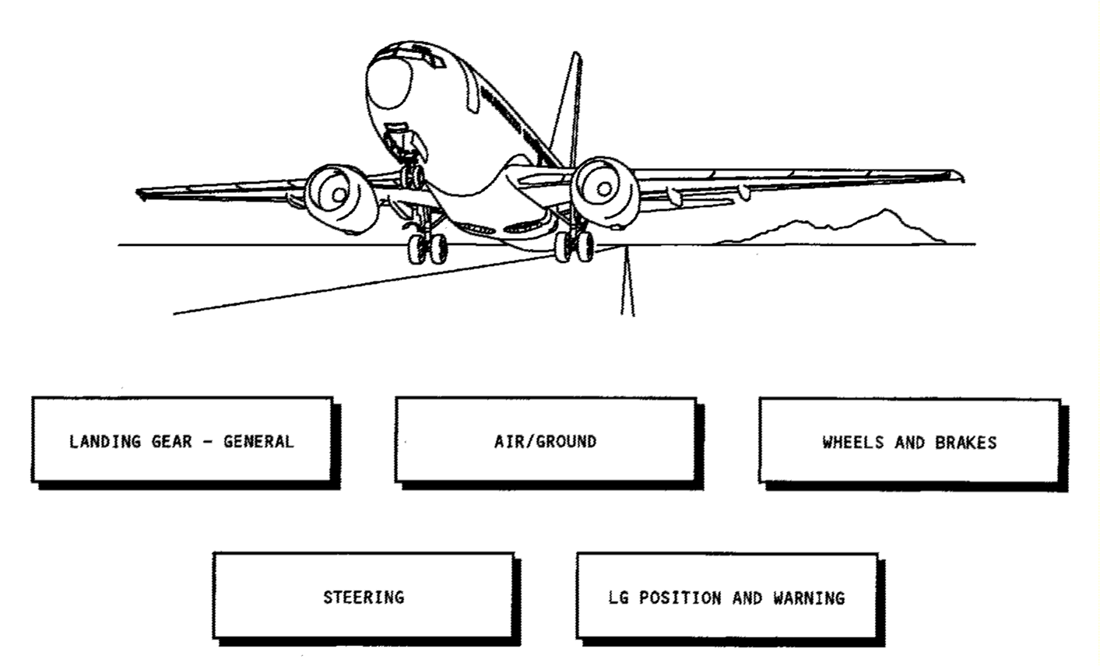

Figure 1 Introduction

GENERAL — INTRODUCTION
Purpose
The landing gear structural components hold the weight of the airplane while the airplane is on the ground. These are the landing gear structural systems:
-The main landing gear (MLG) and doors (32—10)
-The nose landing gear (NLG) and doors (32—20).
The landing gear extension and retraction systems extend and retract the landing gear (32—30). The nose wheel steering system supplies the ground directional control of the airplane (32—50).

Training Information Point
Observe these warnings and cautions when you do maintenance on the landing gear components:
WARNING:
USE NITRILE GLOVES FOR SKIN PROTECTION AGAINST BMS 3-27 (MASTINOX 6856K). IF MASTINOX GETS ON YOUR SKIN, IMMEDIATELY REMOVE IT WITH WATER. IF THIS MATERIAL GETS IN YOUR EYES, IMMEDIATELY FLUSH YOUR EYES WITH WATER AND GET MEDICAL AID. THIS MATERIAL CONTAINS VERY POISONOUS AND FLAMMABLE AGENTS WHICH CAN CAUSE INJURIES TO PERSONS.
CAUTION:
REMOVE UNWANTED MASTINOX FROM SURFACES WHICH WILL BE LUBRICATED. IF YOU APPLY MASTINOX TO JOINTS THAT TURN, FAILURE OF THE LANDING GEAR TO EXTEND OR RETRACT COULD OCCUR.
General
You install a downlock pin into the main landing gear to prevent an outside force from unlocking the main landing gear.
There is one main landing gear downlock pin for each main landing gear.
The downlock pin installs in the MLG downlock strut.
You install a downlock pin into the nose landing gear to prevent an outside force from unlocking the nose landing gear.
There is one nose landing gear downlock pin for the nose landing gear.
The nose landing gear downlock pin installs in the NIG downlock pin hole.

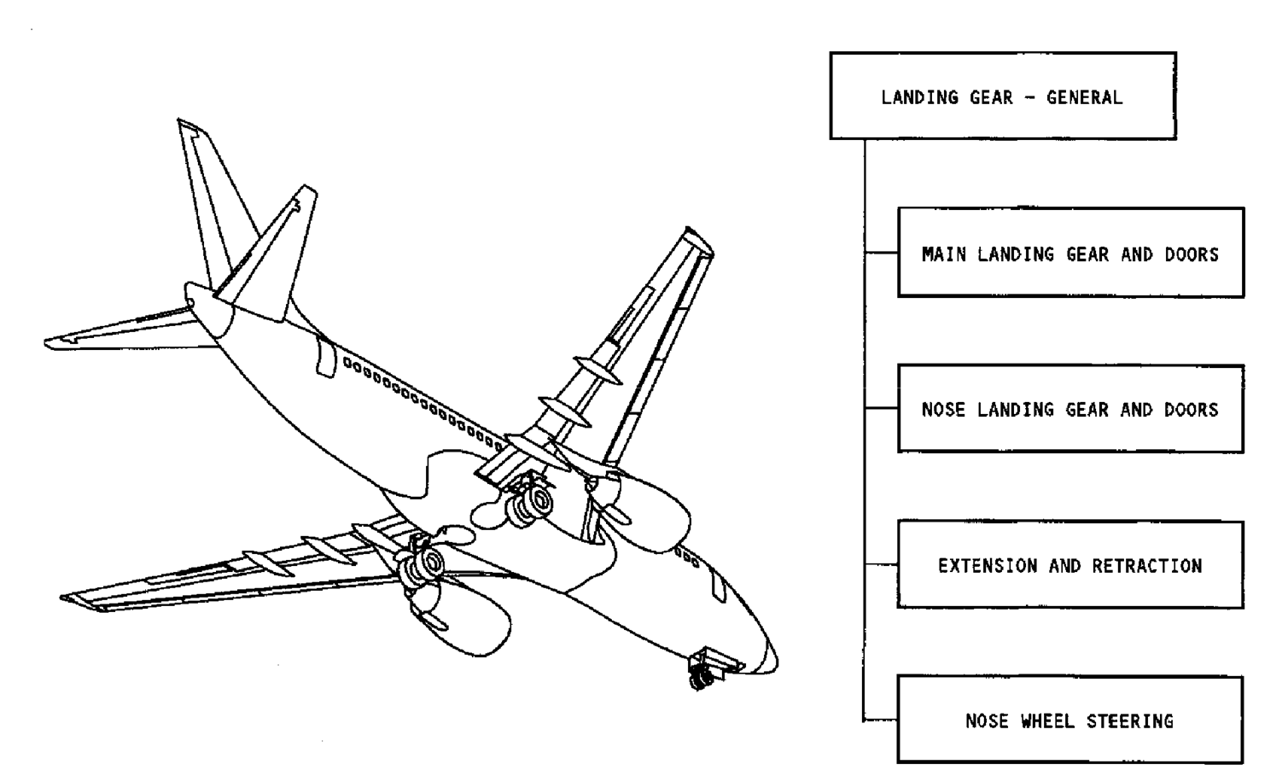

Figure 2 General – Introduction
MAIN LANDING GEAR AND DOORS — INTRODUCTION
Purpose
The two main landing gear (MLG) absorb landing forces and hold most of the airplane weight when the airplane makes a landing. The main landing gear also landing gear wheel well (not shown). They make an aerodynamic seal around transmits the braking forces to the airplane structure.
Main Landing Gear
Each main landing gear has two wheels. The side strut holds the main landing gear in the extended position. The side strut has an upper and a lower part. A down lock strut moves to an over—center position to lock the main landing gear in the down position.
Each main landing gear has these components:
-Shock strut,-Torsion links,-Side strut,-Reaction link,-Down lock strut.
A jack pad is on the bottom of the shock strut. The jack pad permits the inner cylinder to be moved up for wheel and tire replacement.
Main Landing Gear Shock Strut Doors
These are the three doors for each main landing gear:
-Outer door
-Center door
-Inner door.
The MIG shock strut doors open to let the main landing gear extend and retract. The doors aerodynamically seal the opening in the lower surface of the wing and the wing to body fairing.
There are no wheel well doors. The outboard surface of the outboard wheels operate as aerodynamic covers for the main gear wheel well when the main landing gear retracts. The wheel well seal system supplies an aerodynamic seal around the outboard tire.
Main Landing Gear Wheel Well Seal System
There are blade—type seals around the openings in the bottom of the main landing gear wheel well (not shown). They make an aerodynamic seal around the outboard tire when the main landing gear retracts.
SHOCK STRUT  Purpose  The main landing gear shock struts absorb landing forces and transmit vertical loads to the airplane structure.  Physical Description  The shock struts are standard air—oil shock absorbers. They have an inner cylinder which moves in an outer cylinder.  Compressed nitrogen is in the upper part of the shock strut. BMS (Boeing Material Specification) 3—32 landing gear shock strut fluid is in the lower part of the shock strut. BMS 3—32 fluid is a mixture of MM—H—5606 hydraulic fluid and additives.  Torsion links on the forward part of the shock strut connect the inner and outer cylinders.  The main landing gear axle attaches to the bottom of the inner cylinder. You can remove and replace the axle if it gets damaged.  Shock Strut Seals  A static and a dynamic seal between the inner and outer cylinders keep the mixture of nitrogen and hydraulic fluid in the shock strut.  There are two spare static seals and two spare dynamic seals in the shock strut. These let you remove and  replace defective seals without removal of the inner cylinder.  Training Information Point  Use plastic tools when you remove and install the shock strut seals to prevent damage to the inner cylinder.  Measure the distance the gland nut extends below the outer cylinder before and after you remove and install the gland nut. If the distance is larger after installation than it was before, there is an obstruction that prevents proper gland nut installation. | WARNING: DO NOT LOOSEN THE VALVE BODY UNLESS THE SHOCK  STRUT IS FULLY DEFLATED. AIR PRESSURE CAN BLOW THE VALVE BODY OUT, AND CAN CAUSE INJURY TO PERSONS.  WARNING:  THE CHARGING VALVE MUST STAY OPEN. INTERNAL PRES SURE CAN BLOW OUT THE GLAND NUT AND CAN CAUSE IN JURY TO PERSONS.  WARNING:  WHEN AN AIRPLANE LOWERS RAPIDLY, IT CAN CAUSE IN JURY TO PERSONS AND DAMAGE TO EQUIPMENT.  CAUTION:  YOU MUST BE VERY CAREFUL NOT TO CAUSE DAMAGE TO THE INNER CYLINDER. NICKS OR SCRATCHES ON THE INNER CYLINDER WILL CAUSE DAMAGE TO THE CENTERING CAM AND THE SEALS. THIS DAMAGE WILL OCCUR AS THE SEALS MOVE OVER THE DAMAGED SURFACE OF THE INNER CYLIN DER.  CAUTION: HAVE EQUIPMENT OR MANPOWER READY TO SUPPORT  WEIGHT OF INNER CYLINDER AS CYLINDER COMES OUT. IN NER CYLINDER CAN BE DAMAGED IF DROPPED.  CAUTION: THE GLAND NUT AND THE OUTER CYLINDER MAY HAVE  BEEN REWORKED (OVERSIZE). MAKE SURE YOU IDENTIFY THEM AS REWORKED (OVERSIZE) AND KEPT AS A SET.

Main Landing GEAR SHOCK STRUT DOORS
General
The main landing gear shock strut doors cover the opening in the wing for the shock strut when the main landing gear retracts. The main landing gear shock strut doors have the following components:
-Outer door
-Center door
-Inner door.
Outer Door
The outboard edge of the outer door turns on a hinge. The outer door hinge is on the airplane wing structure along the outboard edge of the door. The outer door control rod connects to the shock strut trunnion. It operates the outer door.
Center Door
The center door attaches to the shock strut.

Inner Door
The inner door turns on a hinge on the center door. A control rod connected to the lower side strut operates the inner door.
Training Information Point
Be careful when you move around the inner door. The sharp point on the inner door can cause injury to persons.
CAUTION:
MAKE SURE THAT THE STRUT DOORS ARE CLEAR OF THE WING PANELS BEFORE YOU FULLY RETRACT THE GEAR.THE STRUT DOORS CAN CAUSE DAMAGE TO THE WING PANELS IF THE DOORS ARE NOT CLEAR.
MAIN GEAR DAMPER
Purpose
The main gear damper decreases vibration between the inner and outer cylinders during high speed taxi and heavy brake use. The main gear damper contains these components:-Housing assembly-Piston-Bleed plugs-Manifold assembly-Inlet check valve-Relief valve-Compensator.
Location
The body of the main gear damper attaches to the forward end of the upper torsion link.
Functional Description
Vibration between the inner and outer cylinders causes the inner cylinder to turn inside the outer cylinder. This causes the main gear damper piston to move from side to side inside the housing assembly.
When the piston moves, hydraulic fluid moves through the damping orifices. This decreases piston movement. The damper connects to the return line of the main landing gear actuator.
The compensator maintains system pressure between 18 and 33 psi.
The inlet check valve controls the hydraulic fluid flow rate into the damper to 70 cu in/min at 50 psi. It also controls the fluid that leaves the damper to 14 cu in/min at 3750 psi.
The relief valve protects the compensator if the pressure increases to more than 240 psi.

Training Information Point
Use the two bleed plugs on the main gear damper to remove trapped air when you install a new damper.

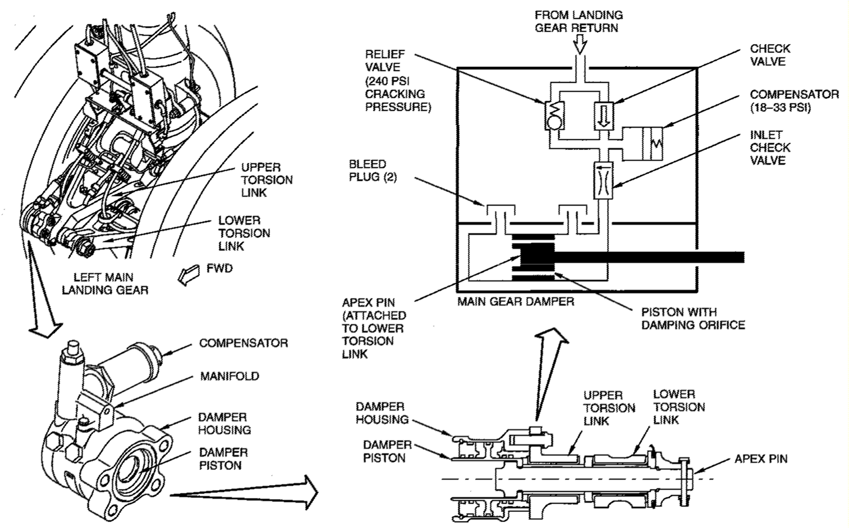
Figure 11 Main Gear Damper

UNIT 5
Fuel System – Introduction
General
The fuel system has these subsystems: -Fuel storage; Pressure fueling; Engine fuel feed; APU fuel feed; Defuel; Fuel quantity indicating system; Fuel temperature indication.
Fuel Storage
The fuel storage system has three tanks: -Main tank No. 1 -Main tank No. 2
-Center tank.
Pressure Fueling System
The pressure refueling system fuels each fuel tank. The fueling panel (P15) controls fueling operations.
Engine Fuel Feed System
The engine fuel feed system supplies fuel from each fuel tank to the engines. The fuel system panel CP5) controls engine fuel feed.
APU Fuel Feed
The APU fuel feed system supplies fuel to the APU. Any fuel tank can supply fuel to the APU.
Defuel System
The defuel system permits the removal of fuel from each tank. It also permits the transfer of fuel between tanks on the ground.
Fuel Quantity Indicating System
The fuel quantity indicating system (FQIS) shows fuel weight on the common display system (CDS) and the refuel panel (P15).
Fuel Temperature Indicating System
Fuel temperature, in the left wing, is shown on the fuel system panel (P5).

Abbreviations and Acronyms
APU— auxiliary power unit; CDS— common display system;
FQIS— fuel quantity indicating system ; Kg’s— kilograms
lbs— pounds

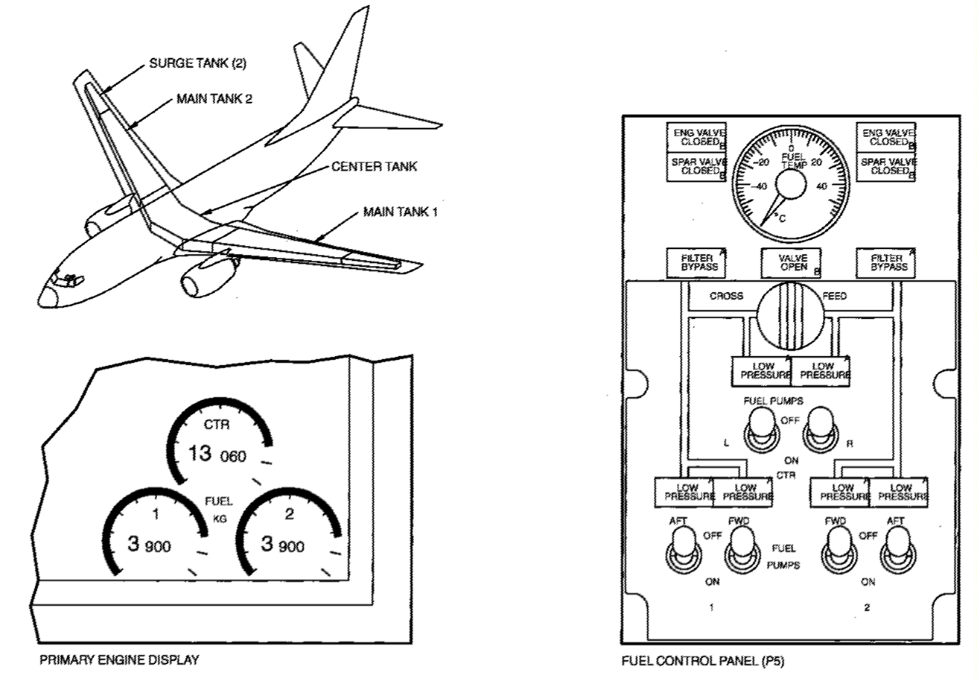

Figure 1 Introduction

Fuel Storage – General Description Fuel
Tank Arrangement
These are the fuel tanks:-Main tank 1; -Main tank 2; -Center tank.
Surge tanks collect fuel overflow only. The fuel overflow in the left wing surge tank drains to main tank 1. The fuel overflow in the right wing surge tank drains to main tank 2. If the fuel level is high enough in the surge tank fuel drains out the vent scoop.
Component Location
Main tank 1 is in the wing box of the left wing. Main tank 2 is in the wing box of the right wing. The center tank is in the fuselage and the left and right wing root.
Capacity
The capacity of main tank 1 is 8,630 lbs (3,915 kgs). The capacity of main tank 2 is 8,630 lbs (3,915 kgs). The capacity of the center tank is 28,830 lbs (13,066 kgs). Fuel tank capacity does not include surge tanks. The capacity of each surge tank is 235 lbs (107 kgs).
Fuel Tank Access
General
Wing fuel tank access panels permit entry into each fuel and surge tank. The wing fuel tank access panels are on the bottom wing skin. One center tank access panel permits entry into the center tank through the fuselage. This panel is in the left air conditioning compartment. Wing ribs divide the fuel tanks into bays. Wing fuel tank access panels are between the wing ribs. Access across wing ribs to adjacent bays is through cutouts. Wing rib 8, in main tank 1 and main tank 2, has check valves. The check valves let fuel flow inboard but do not let fuel flow outboard. Tank end ribs close the ends of each fuel tank. There is no fuel flow through the tank end ribs.
Fuel Tank Locations
The side of body rib is rib 1. Main tank 1 is between rib 5 and rib 22. The location of main tank 2 is the same. The center tank is between rib 5 in the left wing and rib 5 in the right wing. The surge tank for main tank 1 and main tank 2 is between rib 22 and rib 25.
Fuel Tank Access Panels
The fuel tank access panels attach to the bottom wing skin with a clamp ring. An aluminum gasket supplies a proper fit and an electrostatic bond. Impact resistant fuel tank access panels are in areas that are subject to impact damage. The three inboard fuel tank access panels, on each wing, are impact resistant panels.
Sump Drain Valves
General
The sump drain valves let these drain from each fuel tank: -Fuel ; Water; Contamination.
Sump drain valves are at the low point of each tank. The sump drain valves in these tanks attach to the bottom wing skin:-Main tank 1;Main tank ;Surge tank.
The sump drain valve in the center tank attaches to the lower wing skin panel.
Component Location
The sump drain valve for main tank 1 and main tank 2 is outboard of rib five. The sump drain valve for the center tank is near the center of the tank. You get to the sump drain valve from an access door on the lower fuselage skin. The access door is between the two air conditioning access doors. The sump drain valve for the surge tanks is outboard of rib 22. The sump drain valve is on the bottom of the wing.
Operation
The procedure to drain fluid from these tanks is the same:-Main tank 1-
Main tank 2-Surge tank.
To open the sump drain valve, push up on the center of the valve. An internal spring closes the sump drain valve. To drain fluid from the center tank, open the access door and pull down on the rod. An internal spring closes the sump drain valve.
Training Information Point
You can replace the primary seal of a main tank sump drain valve by removing the valve core plug and valve poppet. Defueling the main tank is not necessary. However, you must defuel the tank if you need to replace the whole main tank drain valve. You may replace the center tank sump drain assembly without defueling the center tank.
Fuel Vent System
General
The fuel vent system keeps the pressure of the fuel tanks near the ambient pressure. Too large of a pressure difference can cause damage to the wing structure. Drains let fuel in the vent system return to the tanks. Flame arrestors make sure excessive heat does not enter the fuel vent system. A clogged flame arrestor causes the pressure relief valve, in the surge tank, to open. When open, the pressure relief valve becomes another vent for the fuel vent system.
Component Locations
Stringers and the upper wing skin make the vent channels. The vent channels have drain float valves in the center tank. Vent tubes attach to vent channels. Each vent tube has a drain float valve. A fuel vent float valve is on the outboard fuel tank end rib in main tank No. 1 and main tank No. 2. A surge tank drain check valve is on the outboard fuel tank end rib in main tank No. 1 and main tank No. 2. The vent scoop and pressure relief valve are on an access door in each surge tank.
Functional Description
Vent channels and vent tubes equalize the pressure between each tank and the surge tanks when the airplane is in a climb attitude. The surge tanks are open to the atmosphere through the vent scoop. The fuel vent float valves equalize the pressure between main tank No. 1, main tank No. 2 and the surge tanks when the airplane is in a cruise or descent attitude. The drain float valves in the vent tubes and the vent channels permit fuel, in the vent system, to drain into the tank when the fuel level is lower than the valve. The surge tank drain check valve permits fuel in the surge tank to flow to either main tank No. 1 or main tank No. 2. The surge tank drain check valve also prevents fuel flow from main tank No. 1 and main tank No. 2 to the surge tank. The pressure relief valve prevents damage to the wing structure when there is too much positive or negative pressure in the fuel tanks. The pressure relief valve is usually closed. When closed, it is even with the bottom surface of the wing. With too much positive or negative pressure, the pressure relief valve opens. When open, part of the pressure relief valve is in the fuel tank. Once opened, the pressure relief valve remains in the open position. In the open position, the pressure relief valve, supplies an additional vent in the surge tank. Pull the reset handle to move the pressure relief valve to the closed position. For normal operations, make sure the pressure relief valve is closed. An open pressure relief valve is a symptom of a problem in the fuel vent system.
Center Tank Scavenge System
General
The center tank fuel scavenge system increases the quantity of fuel you can use.
Functional Description
The left forward boost pump supplies motive flow to a jet pump. The jet pump removes fuel from the center tank and transfers it to main tank 1. The jet pump has no parts that move. It is on the left front spar. A fuel scavenge shutoff valve controls fuel sent to main tank 1. When the fuel level in main tank 1 decreases to 4,487 lbs (1,990 kgs) the float valve opens. The minimum fuel transfer rate for the fuel scavenge system is 220 lbs/hour (100 kgs/hour). The fuel transfer rate for the fuel scavenge system is generally between 220 lbs/hour (100 kgs/hour) and 450 lbs/hour (200 kgs/hour).
UNIT 6
Hydraulic system
General Description  There are three independent hydraulic systems that supply hydraulic power for user systems.  The main and auxiliary hydraulic systems supply pressurized fluid to these airplane systems:  -Primary flight controls  -Secondary flight controls  -Landing gear extension and retraction  -Main gear brakes  -Nose wheel steering  -Power transfer unit (PTU) motor  -Both thrust reversers.  These systems make up the hydraulic power system:  -Main hydraulic systems  -Ground servicing system  -Auxiliary hydraulic systems  -Hydraulic indicating systems.  Main Hydraulic Systems  The two systems are A and B. System A has most of its components on the left side of the airplane and system B on the right side.  Ground Servicing System  The hydraulic servicing system fills all hydraulic reservoirs from one central location.  Auxiliary Hydraulic Systems  The two auxiliary systems are the standby hydraulic system and the power transfer unit (PTU) system. | The standby hydraulic system supplies hydraulic power to these components:  -Rudder  -Leading edge flaps and slats  -Both thrust reversers.  The PTU is the alternate source of hydraulic power for the leading edge flaps and slats.  Hydraulic Indicating System  These are the indicating systems:  -Hydraulic fluid quantity  -Hydraulic pressure  -Hydraulic pump low pressure warning  -Hydraulic fluid overheat warning.  The hydraulic indicating system shows these indications in the flight compartment:  -System pressure  -Reservoir quantity  -Pump low pressure lights  -Electric pump overheat lights  -Standby reservoir low quantity light.  Training Information Point  The hydraulic systems use BMS 3—11 TYPE IV erosion arresting, fire resistant hydraulic fluid.  WARNING:  HYDRAULIC FLUID, BMS 3—11, CAN CAUSE INJURY TO PER SONS. IF YOU GET THE HYDRAULIC FLUID ON YOUR SKIN, FLUSH YOUR SKIN WITH WATER. IF YOU GET HYDRAULIC FLUID IN YOUR EYES, FLUSH YOUR EYES WITH WATER AND GET MEDICAL AID. IF YOU EAT OR DRINK THE HYDRAULIC FLUID, GET MEDICAL AID.
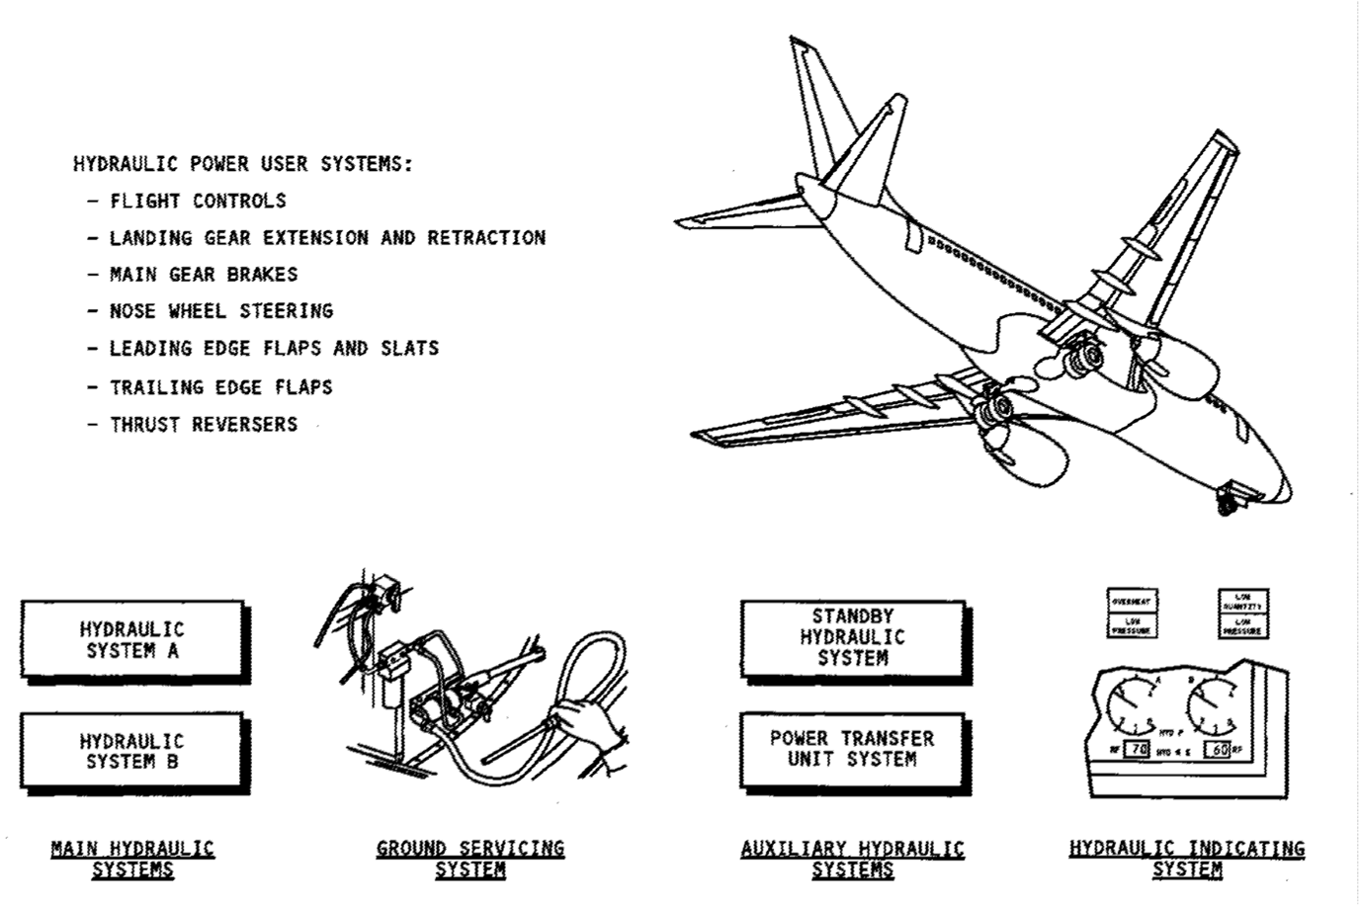

Figure 1 Introduction
GENERAL DESCRIPTION  Pressurization  Air pressure from the reservoir pressurization system maintains head pressure on hydraulic system A, system B, and the standby hydraulic system reservoirs.  The pressurized reservoirs supply a constant flow of fluid to the hydraulic pumps.  Hydraulic System A  Hydraulic system A supplies pressure to these airplane systems:  -Aileron  -Autopilot A  -Elevators  -Elevator feel  -Rudder  -Flight spoilers 2, 4, 9, and 11  -Ground spoilers 1, 6, 7, and 12  -Left thrust reverser  -Alternate brakes  -Nose wheel steering  -Landing gear extension and retraction  -Power transfer unit motor. | Hydraulic System B  Hydraulic system B supplies pressure to these airplane systems:  -Aileron  -Autopilot B  -Elevators  -Elevator feel  -Rudder  -Flight spoilers 3, 5, 8, and 10  -Right thrust reverser  -Normal brakes  -Alternate nose wheel steering  -Alternate landing gear retraction  -Trailing edge flaps  -Leading edge flaps and slats.  Standby Hydraulic Svstem  The standby hydraulic system supplies alternative hydraulic pressure to these airplane systems:  -Standby rudde  -Both thrust reversers  -Leading edge flaps and slats.  Power Transfer Unit  The power transfer unit (PTU) is a hydraulic motor—pump that supplies alternative pressure to leading edge flaps and slats and autoslat system if system B is de-pressurized. The PTU is controlled by the PTU control valve.  System A pressurizes the motor when the PTU control valve is open. System B supplies the fluid to the pump.

CONTROL AND INDICATIONS  General  These are the hydraulic indications in the flight deck for hydraulic systems A and B:  -System pressure  -Quantity  -Pump low pressure  -Overheat (EMDPs only).  These are the indications for the standby hydraulic system:  -Low quantity  -Low pressure  -StbyRud On  Hydraulic Pressure Indication  Hydraulic pressure shows on the lower center display unit systems display for systems A and B.  Hydraulic Fluid Quantity Indication  Hydraulic fluid quantity shows in percent of full, on the lower center display unit systems display for systems A and B reservoirs.  The LOW QUANTITY amber light to the right of the FLT CONTROL switches on the flight control panel comes on when the hydraulic fluid quantity decreases to less than normal in the standby hydraulic system reservoir.  Hydraulic Pump Low Pressure Warning Indication  The amber LOW PRESSURE light for each pump comes on when the pump output pressure is less than normal.  hydraulic panel.  CONTROL switches on the flight control panel. | Hydraulic Fluid Overheat Warning Indication  The amber OVERHEAT lights for the hydraulic system A and B EMDPs are above the pump control switches. The lights come on when the pump case drain temperature increases to more than normal.  The standby hydraulic system does not have an overheat indicator.  Master Caution  When any of the amber lights on the hydraulic control panel come on, the MASTER CAUTION light and HYD light on the P7 panel also come on. When any of the amber lights on the flight control panel come on the MASTER CAUTION light and FLT CONT light on the P7 panel also come on.
COMPONENT LOCATIONS
General
The components for the main, auxiliary, and ground servicing hydraulic systems are in these locations:
- Main landing gear wheel well
- Engine accessory gearbox
- Main fuel tanks
- Aft wing—to—body fairing.
Main Hydraulic Systems
The hydraulic system A and B components are almost the same. The system A components are on the left side of the airplane and system B components are on the right side of the airplane.
These are the components in the main landing gear wheel well for each
main hydraulic system:,- Hydraulic reservoir,- Electric motor driven pump (EMDP),- Engine driven pump supply shutoff valve,- Pressure module
- EMDP Case drain filter module,- Return Filter Module.
The system A engine driven pump (EDP) and the EDP case drain filter
module are on the left engine. The system B EDP and EDP case drain
filter module are on the right engine.
Standby Hydraulic System
These are the components in the main landing gear wheel well for the standby hydraulic system:
- Hydraulic reservoir
- System module
- Case drain filter module.
The standby system hydraulic pump is in the aft wing— to—body fairings.
Other Hydraulic System Components
The
-Power transfer unit (PTU),-PTU pressure filter module,-PTU flow limiter
-PTU control valve and the,-EDP pressure switch auto slat system is in the main landing gear wheel well.
The heat exchangers are in main fuel tanks 1 and 2.
The ground servicing system components are in the right forward corner of the main wheel well. The ground service disconnect for system A is in the left ram air bay. The disconnect for system B is in the right ram air bay.
OPERATION

General
You can pressurize the hydraulic systems with a ground service cart or with the hydraulic pumps.
Ground Service Cart Pressurization
To pressurize hydraulic system A, connect a ground service cart to the left ground service disconnect.
To pressurize hydraulic system B, connect a ground service cart to the right ground service disconnect.
You can not pressurize the standby system from a ground service cart.
Hydraulic Pump pressurization
You use the hydraulic panel on the P5 overhead panel to turn on the hydraulic pumps for system A and B.
You use the flight control panel on the P5 overhead panel to turn on the standby pump.
You can pressurize system A and system B with either an engine- driven pump (EDP) or an electric motor-driven pump (EMDP). The ELEC 1 and ELEC 2 switches on the hydraulic panel let you control the EMDPs. The hydraulic LOW PRESSURE light is off when the hydraulic pressure is normal.
Usually, the ENG 1 and ENG 2 switches are in the ON position. When the engines are on, the EDPs come on to also pressurize systems A and B. If you move the ENG switches to the OFF position, this will stop pump output pressure.
An OVERHEAT light monitors system A and system B only. The standby hydraulic system does not have an overheat light.
Training Information Point
If you pressurize the hydraulic systems with the hydraulic pumps, make sure there is sufficient fuel in the main fuel tanks to cool the heat exchangers.
To pressurize a hydraulic system with a ground service cart, you first must remove the pressure from the hydraulic reservoir.
WARNING: KEEP PERSONS AND EQUIPMENT AWAY FROM ALL CONTROL SURFACES AND THE NOSE GEAR WHEN HYDRAULIC POWER IS SUPPLIED. THE AILERONS, ELEVATORS, RUDDER, FLAPS, SLATS, SPOILERS, AND THE NOSE GEAR ARE SUPPLIED WITH POWER BY THE HYDRAULIC SYSTEMS. IN JURIES TO PERSONS OR DAMAGE TO EQUIPMENT CAN OCCUR WHEN HYDRAULIC POWER IS SUPPLIED.
CAUTION: YOU MUST MONITOR THE INSTRUMENTS AND INDICATOR
LIGHTS FOR THE HYDRAULIC SYSTEMS WHEN HYDRAULIC SYSTEMS ARE PRESSURIZED. THIS IS TO MAKE SURE THE HYDRAULIC SYSTEMS OPERATE CORRECTLY. IF THE OVER HEAT LIGHT OF A HYDRAULIC SYSTEM COMES ON, YOU MUST STOP THE OPERATION OF THAT HYDRAULIC SYSTEM IMMEDIATELY. DAMAGE TO THE EQUIPMENT CAN OCCUR IF YOU DO NOT DO THIS.
CAUTION: DO NOT OPERATE THE EMDP FOR MORE THAN TWO MINU TES IF THE NO. 1 FUEL TANK CONTAINS LESS THAN 250 GALLONS (1675 POUNDS/761 KILOGRAMS) OF FUEL. YOU MUST LET THE RESERVOIR TEMPERATURE DECREASE TO AMBIENT TEMPERATURE BEFORE YOU OPERATE THE PUMP AGAIN. DAMAGE TO EQUIPMENT CAN OCCUR IF YOU DO NOT DO THIS.
FUNCTIONAL DESCRIPTION

General
Two independent hydraulic systems supply power to airplane systems. The standby hydraulic system supplies an alternative source of power.
Hydraulic Reservoir Pressurization System
The hydraulic reservoir pressurization system supplies air from the pneumatic system to the reservoir. This pressurizes the supply hydraulic fluid for the pumps.
Hydraulic System A
The pressure sources for hydraulic system A are an engine driven pump (EDP) on engine number one and an electric motor driven pump (EMDP) in the main wheel well. Both pumps supply pressure to these airplane systems:
-Primary flight controls,-Four flight spoilers,-Four ground spoilers
-Landing gear extension and retraction,-Alternate brakes,-Left thrust reverser.
Hydraulic System B
The pressure sources for hydraulic system B are an engine driven pump (EDP) on engine number two and an electric motor driven pump (EMDP) in the main wheel well. Both pumps supply pressure to these airplane systems:
-Primary flight controls,-Four flight spoilers,-Trailing edge flaps,-Leading edge flaps and slats,-Normal brakes,-Right thrust reverser.
System B supplies an alternative hydraulic power source for gear retraction and nose wheel steering.
Standby Hydraulic System
The pressure source for the standby hydraulic system is an electrical motor
driven pump (EMDP). The standby hydraulic system operates as an alternative
system that supplies hydraulic power for these systems:
- Rudder,- Thrust reversers,- Leading edge flaps and slats.
You operate the standby system manually with the FLT CONTROL switches or
the ALTERNATE FLAPS arm switch.
The standby system operates automatically if all of these conditions are true:
One FLT CONTROL switch to ON
- Trailing edge flaps not up,- Airplane in the air or wheel speed more than 60 knots,- Low flight control pressure.
Hydraulic Power Transfer Unit (PTU) System
The hydraulic power transfer unit (PTU) is a hydraulic motor pump that supplies
an alternative source for power for the operation of leading edge flaps and
slats. The PTU system operates automatically when these conditions occur: Airplane in the air
- Trailing edge flap position between up and 15,- System B EDP low pressure.
Hydraulic Indicating System
The hydraulic indicating system shows these indications in the flight deck:
- System pressure- Reservoir quantity- Pump low pressure
- Hydraulic system A & B EMDP overheat
- Standby reservoir low quantity.
Ground Servicing System
The ground servicing system fills all hydraulic reservoirs from one central location.
Task 1. Translate into Russian:

Maintenance Manual
Preparation for flight.
Anti-icing is the use of fluids on a clean aircraft to prevent snow, ice or frost from its surfaces. A coating of anti-icing fluid applied to a clean aircraft may protect it from snow, ice and frost.
De-icing is the use of heated water or mixtures to remove snow, ice and frost. Apply anti-icing fluid after de-icing as a preventive measure.
Chocks are positioned. The engines are shut down. Brakes set. Brakes released.
Tanks are equipped with a drain plug and a filler cap. Water pump is connected to the outlet of the water tank. The outlet of the main pump is connected with a valve: one way to the water delivery hose, the other to the cleaning system of the waste tank. There is a relief valve to regulate the pressure.
A meter indicates the quantity of water delivered to the aircraft. Hoses: a rinsing water hose is connected to the water pump via a control valve. The hose is stowed on a hose reel.
An additional tank for disinfecting fluid.
Water heater; pump heater; a heating system to maintain the water temperature above freezing point.
A manual water pump.
A damp valve connectable with ground drainage system.
Height steps instead of platform.
Flushing system for the water tank with controls.
A vacuum waste extraction system. A second waste hose.
Couplings and vents to suit pressure filling.
Loading/unloading operations.
Avoid damage to the doors.
Prevent damage to the floor.
The doors should be closed and locked, any steps removed.
Aircraft should be searched prior to the boarding of passengers and after deplaning of passengers. Remove checked baggage, mail, cargo.

Check Questions
- What are the main parts of an aircraft?
- What are the main parts of the airframe?
- What are the structural components of the fuselage?
- What are the stabilizers for?
- What are the types of fuselage’s doors do you know?
- What is the power plant?
- What is the power plant’s function?
- What are parts of the power plant?
- What kinds of engines do you know?
- What is the wing and its function?
- What are the main parts of the wing?
- What is the shape of the wing?
- What are sections of the wing?
- What are the aircraft flight controls?
- What are flight controls used for?
- What are the function and parts of landing gear?
- What is the tail unit consist of?
- What is the vertical surface of tail unit?
- What is the movable part of tail unit?
- What is the horizontal surface of tail unit?
- What is the elevator used for?
- What is the rudder used for?
- What is the landing gear and its function?
- What are the main components of landing gear?
- What is the landing gear comprise of?
- In what position is the landing gear in flight?
- What flight control systems do you know?
- What are the main systems of an aircraft?
- What is APU?
- What are the main subsystems of fuel system?

FUSELAGE / ФЮЗЕЛЯЖ
airframe | планер
bulkhead  pressure bulkhead | балка  гермошпангоут
frame | рама, каркас
fairing | обтекатель
skin  skin panel | обшивка  панель обшивки
cockpit/flight deck | кабина экипажа
cargo compartment | грузовой отсек
passenger cabin | пассажирский салон
door  doors | дверь, створка, лючок  створки
hatch  access hatch | люк  люк для обеспечения доступа
control column,  yoke | штурвальная колонка  ручка управления
control wheel | штурвал
elevator | руль высоты
rudder | руль направления
horizontal stabilizer  vertical stabilizer | горизонтальный стабилизатор  вертикальный стабилизатор
radome | носовой обтекатель(антенны)
tail, tailcone  empennage | хвост, хвостовой обтекатель  хвостовое оперение
window | окно, иллюминатор
windshield, windscreen | лобовое стекло
wipers | дворники - стеклоочистители
WING / КРЫЛО
wing  wingtip  winglet | крыло  законцовка крыла  концевая аэродинамическая поверхность
aileron | элерон
flap | закрылок
longeron  spar | лонжерон(фюзеляжа)  лонжерон
rib | нервюра
slat | предкрылок
spoiler | спойлер
stringer | стрингер

HYDRAULIC & PNEUMATIC SYSTEMS /
ГИДРАВЛИЧЕСКАЯ И ПНЕВМАТИЧЕСКАЯ СИСТЕМЫ
air  air bleed | воздух  отбор воздуха
accumulator | аккумулятор
duct | трубопровод
hose | гибкий трубопровод
manifold | магистральный трубопровод
sleeve | рукав
pipe | труба
hydraulic fluid | гидрожидкость
pump  electric motor driven pump  engine driven pump  jet pump | насос  насос с электроприводом  насос с приводом от двигателя  энжекционный насос
valve  check valve  pressure relief valve  butterfly valve  crossfeed valve  spring-loaded valve  bypass valve  isolation valve | клапан  обратный клапан  клапан стравливания  лепестковый клапан  клапан кольцевания  пружинный клапан  обходной клапан  изолирующий клапан

LANDING GEAR / ШАССИ
nose landing gear  main landing gear | носовая стойка шасси  основная стойка шасси
wheel well | ниша шасси
nose wheel steering | система управления разворотом колеса передней стойки шасси
autobrakes  speedbrakes  parking brake | автоматическая система торможения  спойлеры, использующиеся для аэродинамического торможения ВС  стояночный тормоз
pin | палец, штырь, контакт типа "папа"
strut  drag strut  shock strut | стойка  боковой подкос  амортстойка, амортизационная опора (шасси)
extend  retract | выпускать  убирать
skid  anti-skid | юз  антиюз
shimmy damper | демпфер Шимми
tire | авиашина, пневматик
inflate  deflate | надувать  понижать давление
wheel  wheel chocks | колесо  колодки

FLIGHT INSTRUMENT / ПИЛОТАЖНЫЕ ПРИБОРЫ
altitude | высота
angle of attack | угол атаки
arrow  pointer | стрелка  указатель
scale | шкала
range | диапазон (по дальности)
band | диапазон (радиочастот)
chime | звуковой сигнал (колокольный)
horn | звуковой сигнал (горн)
annunciator | световая сигнализация
data  database | данные, информация  база данных
display | дисплей
feedback | обратная связь
flight recorder | полетный самописец
gage, gauge | индикатор, манометр
pilot probe  static port | приемник полного давления  приемник статического давления

POWER PLANT (ENGINE, APU) / СИЛОВАЯ УСТАНОВКА (ДВИГАТЕЛЬ, ВСУ)
nacelle | мотогондола
pylon | пилон
jet engine | реактивный двигатель
auxiliary power unit, APU | вспомогательная силовая установка, ВСУ
accessory gearbox | коробка приводов двигателя
annular combustion chamber | кольцевая камера сгорания
assemble  assembly | собирать  сборка, в сборе
mount  mounting | крепить  крепление
bear (bore, born)  bearing | выдерживать (нагрузку)  подшипник
blade | лопатка
vane | лопасть
case | корпус агрегата
cowl | капот
shroud | кожух
compress  compressor  high pressure compressor, HPC  low pressure compressor, LPC | сжимать  компрессор  компрессор высокого давления  компрессор низкого давления
high pressure turbine, HPT  low pressure turbine, LPT | турбина высокого давления  турбина низкого давления
torque | крутящий момент
shaft  torque shaft | вал  вал, передающий крутящий момент
clearance | зазор
hot start  wet start  hung start | горячее зависание  ложный запуск  зависание оборотов при запуске
pressure  pressurize | давление  нагнетатель
pressurization | герметизация, наддув
depressurization | разгерметизация
bleeding / releasing | стравливание избыточного давления
differential pressure | перепад, разность давлений
idle | малый газ
ignite  ignition  igniter plug | зажигать  зажигание  свеча зажигания
muffler | глушитель
rod | тяга (механизм)
thrust  thrust reverser | тяга (сила)  устройство реверса тяги
spin  spinner | крутиться  кок (вентилятора)
stage | ступень
start | запуск
run up | гонка
stop | остановка
shutdown | выключение

FUEL SYSTEM / ТОПЛИВНАЯ СИСТЕМА
fuel | топливо
fuel depletion | полная выработка топлива
fuel low | расход топлива
fueling station | панель заправки топливом (включая агрегаты)
fuel nozzle | топливная форсунка
fuel tank | топливный бак
float switch | поплавковый датчик
fuel vapors | пары топлива
fueling | заправка ВС топливом (процесс)
refueling | заправка ВС топливом (процедура)
defueling | слив топлива
jettison pump | насос сброса топлива
gravity fueling | заправка через горловины на верхней поверхности крыла
pressure fueling | заправка под давлением
booster fueling | насос подкачки
purge, purging | принудительная вентиляция для удаления паров топлива из топливного бака

AIRCRAFT MAINTENANCE / ТЕХНИЧЕСКОЕ ОБСЛУЖИВАНИЕ ВС
adjust  adjustment | регулировать  регулировка
analyze  analysis | анализировать  анализ
bolt | болт
nut | гайка
rivet | заклепка
screw | винт
washer | шайба
screwdriver | отвертка
cutter | резак
drill | дрель
file | напильник
hammer | молоток
pliers | плоскогубцы
wrench | гаечный ключ
soldering iron | паяльник
amend  change | вносить изменения  изменять
charge  recharge  discharge | заряжать  перезаряжать  разряжать
check  make a check | проверка  проводить проверку
recover  recovery | восстанавливать  возврат в стандартное рабочее состояние, стабилизация, восстановление
clean  cleaning | чистый; очистить  очистка, уборка
complete  completion | завершать, заканчивать; полный, целый  завершение, окончание
leak  leakage | течь  утечка, протекание, течь
ice  icing  anti-icing | лед  обледенение  противо-обледенительный
inspect  inspection | осматривать  осмотр, инспекция
jack | подъем, поднимать, подъемное устройство, домкрат, разъем
lockwire  locknut | контровочная проволока  контргайка
potable water | питьевая вода
procedure | процедура
tow bar | водило
repair  overhaul | ремонт, ремонтировать  капитальный ремонт
replace  replacement | заменять  замена
require  requirement | требовать  требование
rig  rigging | регулировать; собирать, оснащать, монтировать  регулировка; монтаж
troubleshoot  trouble shooting | произвести работы по определению причин нарушения работоспособности системы  работы по определению причин нарушения работоспособности системы
lavatory | туалет

TECHICAL ANOMALIES / ТЕХНИЧЕСКИЕ НАПОЛАДКИ И НЕИСПРАВНОСТИ
bird ingestion | попадание птицы в газовоздушный тракт двигателя
blister  bulge | пузырь  вздутие
contamination | загрязнение, засорение
damage | повреждение
crack  crazing | трещина  образование сетки волосных трещин (на поверхности)
dent | вмятина
shear | деформация поверхности (со сдвигом)
delamitation  ply separation | расслоение  расслаивание многослойного материала авиашины
engine surge | помпаж двигателя
stall | срыв потока
fault | неисправность, сбой в работе
malfunction | неисправность (работа в аварийном режиме)
fail  failure | отказывать; не иметь способности (что-то сделать)  отказ; выход из строя, нарушение работоспособности
flat tire  worn tire  cut tire  burst tire | авиашина с давлением ниже допустимых  изношенная авиашина  авиашина с порезом  разрушенная авиашина
scratch | царапина
jamming  stiff, stuck | заедание  жесткий, тугой, заклинивший
metal fatigue | "усталость металла"
chafing | механическое истирание
fretting | коррозионно-механический износ
noise | шумы, помехи

LIST OF REFERENCES
- Boeing 737-300/400/500 (CFM 56) Boeing 737-600/700/800/900 (CFM 56)/
Amikon Aviation Training Publishers/ www. amikon. aero.com

2. EASA Part-145 Approved Maintenance Organization (AMO)/ www. amikon. aero.com

3. English for Aviation. Sue Ellis, Terence Gerighty/ Oxford University Press Publishers
4. Henry Emery, Andy Roberts. Aviation English./ MacMillan
5. Учебное пособие. Отдел языковой подготовки департамента персонала авиакомпании “ Трансаэро”.

